Date: 30.08.2024
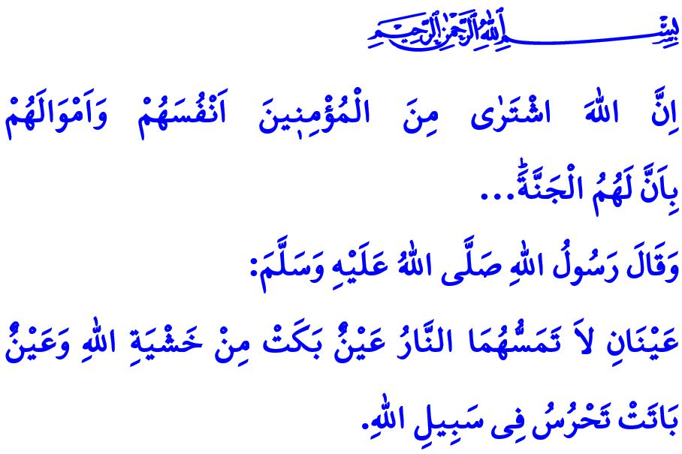
THE SPIRIT THAT MAKES US WHO WE ARE, THE SPIRIT THAT MAKES US A NATION
Dear Muslims!
Homeland means much more to us than a plain piece of land. Our heavenly homeland is the legacy of our ancestors. It is the land of those with knowledge and wisdom. It is what our dear martyrs and heroic veterans have entrusted to us. Our homeland is our peaceful and secure country where we live freely. It is our home where our soul is at peace, our identity shaped, and our roots deepened. Our homeland is the symbol of our independence. It is the place where we run from front to front and sacrifice our lives lovingly so that no heathen would ever lay a hand on it. The love for the homeland is so valuable that our Prophet (saw), in one of his hadiths, heralds those who is on duty for the peace and security of the homeland as follows: "There are two eyes which will never be touched by hell: an eye which weeps from fear of Allah and an eye which spends the night on guard in Allah’s path."
Dear Believers!
In our National Anthem, our love for our homeland is expressed as follows:
Who would not offer his life for this homeland of paradise?
Martyrs would pour forth, all martyrs, should one simply clutch the earth!
If God will, He may take my life, my beloved, and my wealth,
But may He not, for the world, just deprive me of my homeland.
Yes, we, as a nation, consider it a sacred duty to defend our homeland. We wholeheartedly adhere to the verse of our Almighty Lord (swt), وَلَا تَهِنُوا وَلَا تَحْزَنُوا وَاَنْتُمُ الْاَعْلَوْنَ اِنْ كُنْتُمْ مُؤْمِن۪ينَ “Do not falter or grieve, for you will have the upper hand, if you are true believers." We have never lost hope in the face of difficulties. In the face of all kinds of impossibilities, we have fought against the most powerful armies with the strength we have drawn from our faith, our unity and our solidarity. We have put ourselves on the line in defense against all sorts of heinous raids. We have protected our honor and our dignity and we have defended our independence and our future, alhamdulillah.
Dear Muslims!
The spirit that leads us from victory to victory is our wholehearted faith in our sublime religion, Islam. At the heart of this spirit is our devotion to Allah (swt), our love for our beloved Prophet (saw), our performance of good deeds, and our embrace of good morals. When we have embraced this spirit, we have built civilizations that defined the rise and fall of entire eras. We have brought goodness, peace and tranquility to the world. In compliance with the verse "Allah has indeed purchased from the believers their lives and wealth in exchange for Paradise...", we have run to become a martyr or a veteran, as if running towards heaven, without looking back, for the sake of religion, homeland and sanctity, so that the adhan, whose testimonies are the ground of religion, should resound far and wide over our eternal homeland. When we have infused this spirit into every aspect of our lives, we have safeguarded our faith and culture. We have strived to uphold the duty of promoting good and preventing evil, even at the cost of our lives. We have set an example and led all of humanity in knowledge, science, culture, and the arts.
Dear Muslims!
Today, it is our duty to keep alive the spirit that defines us as a nation and to teach our children and youth the values that Islam commands and our Prophet (saw) has embodied throughout his life. It is our duty to preserve the cherished memories of our ancestors and the high values for which our martyrs sacrificed their lives. It is our duty to fulfill our responsibilities for the integrity of our state, the survival of our homeland, and the salvation of our nation. It is our duty to remain vigilant against those who seek to sow seeds of discord and mischief among us, and to never compromise our brotherhood.
I would like to take this opportunity to honor with mercy, gratitude, and appreciation our dear martyrs who have, in the cause of spreading the name of Allah, sacrificed their lives for a homeland where we can live freely and our deceased heroic veterans and statesmen from Badr to Malazgirt, from Çanakkale to the August 30th Pitched Battle of the Commander-in-Chief, and from the July 15th to the present day.
I would like to conclude this Friday's khutbah the following line from our national anthem, which heralds the eternal independence for our beloved nation:
For my flag, who has lived ever freely, has the right to liberty:
For my nation, who worships Allah, has the right to independence!

Tirmidhi, Fadha'il al-Jihad, 12.
Ali 'Imran, 3/139.
Tawbah, 9/111. General Directorate of Religious Services

